**GAOKEview Interactive Flat Panel**

**Specification-Mode E6**

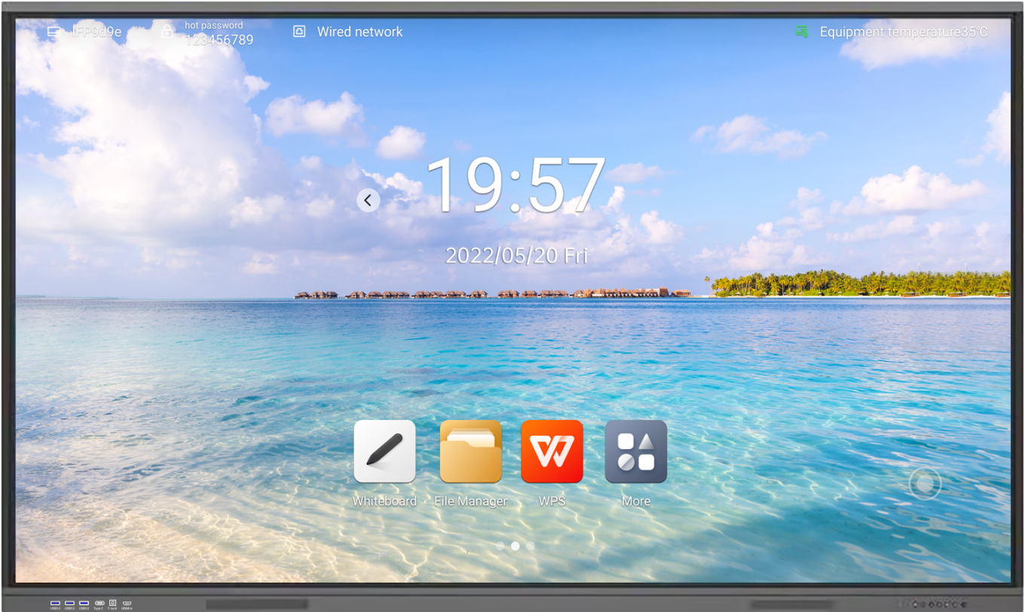

**Product Features**

* **Support stylus magnetic adsorption, convenient for storage**
* **Zero-bonding technology, 4mm anti-glare tempered glass with high haze OC, anti-ambient light interference, clearer display**
* **Support DC dimming (remove screen flash), display more eye protection**
* **With 4K UHD display, supporting full-channel 4K UI display**
* **±1mm high precision infrared touch, smooth writing**
* **Supports two-pen writing at the same time and two-color display, making it easier for multiple people to collaborate**
* **The default front port supports 3*USB3.0 (Android+Windows)+TYPE-C+TOUCH OUT+HDMI IN**
* **With front button(Includes eye-protection button)**

|  |  |  |  |
| --- | --- | --- | --- |
| **Display Parameter** | | | |
| **Size** | **65inch** | **75inch** | **86inch** |
| **Backlight Type** | **D-LED** | **D-LED** | **D-LED** |
| **Panel Brand** | **BOE** | **BOE** | **BOE** |
| **Resolution(pixels)** | **3840x2160** | **3840x2160** | **3840x2160** |
| **Brightness** | **≥400cd/m2(typ.)** | **≥400cd/m2(typ.)** | **≥400cd/m2(typ.)** |
| **Aspect Ratio** | **16:9** | **16:9** | **16:9** |
| **Contrast Ratio** | **4000:1** | **4000:1** | **4000:1** |
| **Response Time** | **6ms (typ.)** | **6ms (typ.)** | **6ms (typ.)** |
| **Pixel Pitch (mm)** | **0.372(H)x0.372(V)** | **0.4298(H)x0.4298(V)** | **0.4875(H)x0.4875(V)** |
| **Refreshing Frequency** | **60Hz** | **60Hz** | **60Hz** |
| **Viewing Angle** | **178°(H)/178°(V)** | **178°(H)/178°(V)** | **178°(H)/178°(V)** |
| **Life Time** | **50,000 Hrs(min.)** | **50,000 Hrs(min.)** | **50,000 Hrs(min.)** |
| **View Area (mm)** | **1428.48(H)x803.52(V)** | **1650.24(H)x928.26(V)** | **1895.04(H)x1065.96(V)** |
| **Color Gamut (X% NTSC)** | **72%(NTSC)** | **72%(NTSC)** | **72%(NTSC)** |
| **Colorfulness** | **1.07B(10 bit)** | **1.07B(10 bit)** | **1.07B(10 bit)** |
| **System** | | | |

|  |  |
| --- | --- |
| **Chipset** | **GK6760V100** |
| **CPU Architecture** | **Octa-core A55** |
| **CPU Working Frequency** | **1.2GHz** |
| **GPU** | **Mali G52MC2** |
| **RAM** | **Standard: 4GB DDR4 Optional: 8GB DDR4** |
| **ROM** | **Standard: 32GB Optional: 128GB** |
| **OS** | **Android 12.0** |
| **Power Requirements** | **AC 100 V ~ 240 V, 50/60 Hz** |
| **65’’ Power Consumption Without OPS** | **180W** |
| **75’’ Power Consumption Without OPS** | **260W** |
| **86’’ Power Consumption Without OPS** | **380W** |
| **Standby Condition** | **< 0.5W** |
| **Speaker** | **2x15W** |

|  |  |
| --- | --- |
| **Front Interface** | |
| **Public USB3.0** | **x3** |
| **Touch USB** | **x1** |
| **HDMI IN** | **x1** |
| **Type-C** | **x1** |
| **Rear Interface** | |
| **RJ45** | **x1** |
| **SPDIF OUT** | **x1** |
| **EARPHONE(3.5mm AUDIO OUT)** | **x1** |
| **TF Card** | **x1** |
| **RS232** | **x1** |
| **HDMI IN** | **x1** |
| **TOUCH USB** | **x1** |
| **USB 2.0(Public USB)** | **x1** |
| **Android USB 2.0** | **x1** |

|  |  |
| --- | --- |
| **Network** | |
| **Wired Network** | **Support 10/100Mbps** |
| **WiFi Standard** | **Built-in dual-channel WIFI, support AP hotspot** |
| **WiFi Protocol** | **WiFi:802.11 b/g/n AP:IEEE802.11a/b/g/n** |
| **WiFi Working Frequency** | **WiFi:2.4GHz AP:2.4GHz** |
| **WiFi Working Distance** | **0~12m** |
| **Bluetooth** | |
| **Standard** | **Built-in** |
| **Version** | **5.0** |
| **Working Frequency** | **2.4GHz+5GHz** |
| **Working Distance** | **0~12m** |
|  | |
| **Camera(Optional)** | |
| **Quantity** | **1** |
| **Pixel** | **13MP/48MP** |
| **Position** | **Middle Top** |
| **Field of vision** | **DFOV: 100° HFOV::91.9° VFOV:60°** |
| **Resolution** | **Support 4K (under Windows)** |
| **Microphone(Optional)** | |
| **Quantity** | **8** |
| **Pick-up Distance** | **0-8m** |
| **View Angle** | **0°~180°** |
| **Touch Parameter** | |
| **Touch Type** | **Infrared Touch Frame** |
| **Surface Protection** | **4mm toughened glass** |
| **Infrared Touch** | **20 Points(Standard)/40 Points(Optional)** |
| **Interpolation Resolution** | **32768 x32768** |
| **Response Time** | **≤6ms** |
| **Input Mode** | **Finger or Pen** |
| **Theory Clicks** | **Unlimited** |
| **Minimum Touch Object** | **USB+RS232** |
| **Connect Type** | **4.75～5.25V** |
| **Structure Parameter** | |

|  |  |  |  |
| --- | --- | --- | --- |
| **Size** | **65inch** | **75inch** | **86inch** |
| **Product Size(L x H x D)** | **1483.8x898x115.8mm** | **1706x1012x116mm** | **1953.2x1152.2x115mm** |
| **Package Size(L x H x D)** | **1615.8x1012x220mm** | **1838x1138x220mm** | **2086x1276x220mm** |
| **Housing Material(Face frame/rear shell)** | **Aluminum/Metal Plate** | **Aluminum/Metal Plate** | **Aluminum/Metal Plate** |
| **Shell color (Face frame/rear shell)** | **Grey/Black** | **Grey/Black** | **Grey/Black** |
| **VESA** | **4-M8 Screw Hole**  **600mmx400mm** | **4-M8 Screw Hole**  **800mmx400mm** | **4-M8 Screw Hole**  **800mmx600mm** |
| **Net Weight** | **45±1KG** | **60±1KG** | **70±1KG** |
| **Gross Weight** | **55±1KG** | **70±1KG** | **83±1KG** |

|  |  |
| --- | --- |
| **Accessory** | |
| **Remote Control** | **x1** |
| **Touch Pen** | **x2** |
| **Power Cord** | **x1** |
| **HDMI Cable** | **x1** |
| **TOUCH USB Cable** | **x1** |
| **E-User’s Manual** | **x1** |
| **Wall Mount** | **x1** |
| **Mobile Stand(Optional)** | **x1** |
| **Environment** | |
| **Working Temperature** | **0℃~40℃** |
| **Working Humidity** | **10%~90%RH** |
| **Storage Temperature** | **-20℃~60℃** |
| **Storage Humidity** | **10%~90%RH** |
| **Working Altitude** | **Below 5000 meters** |
| **Warranty** | |
| **Warranty Time** | **2 Years** |
| **Disclaimer** | |

1.Due to the influence of many aspects such as configuration and manufacturing process, the actual size/weight of this product may vary. The specification is for reference only, please refer to the actual situation.

2.The product pictures attached to this specification are only for illustrative display, the actual effect (including but not limited

to appearance, color, size) may be slightly different, please refer to the actual product.

3.The packaging materials for this product are designed in strict accordance with the storage conditions of this product. 4.Abnormalities caused by extreme weather and long storage time cannot be guaranteed to be completely avoided. Please be informed.

5.Please store in strict accordinate with the required storage conditions. Improper storage may cause abnormalities.

6.In case of any situation involving the above modification and update, no prior notice will be given.

**Product View-65inch**

|  |
| --- |
|  |

**Product View-75inch**

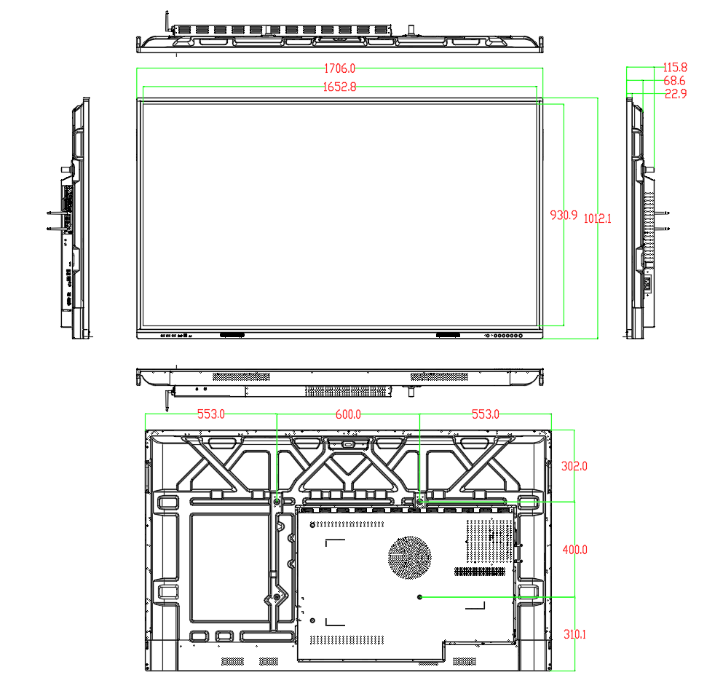

**Product View-86inch**

