**GAOKEview Interactive Flat Panel**

**Specification-Mode A9**

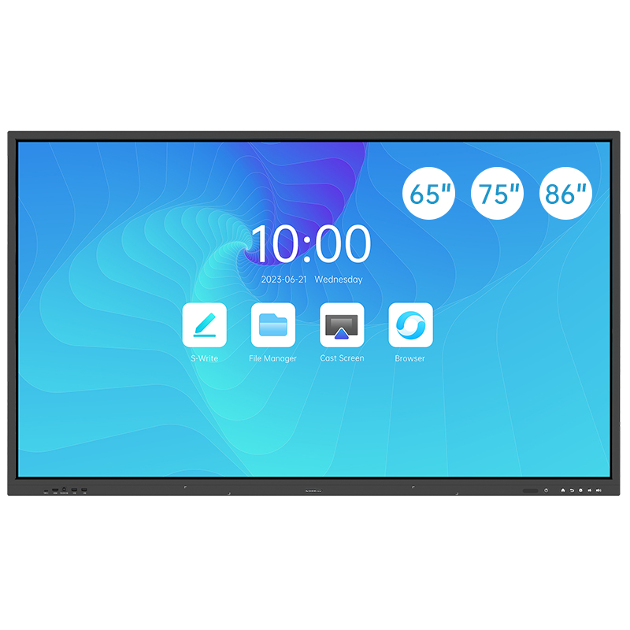

**Product Features**

**◆.The distance between the tempered glass and the screen is close to 0, which preventing the reflection of light effectively, showing excellent effect and excellent writing experience.**

**◆.High accuracy touch screen, supporting 1 point 2.0mm precision writing and 6 points 2.8mm simultaneous writing.**

**◆.Writing height below 3mm to bring smoother writing experience.**

**◆.All-channel annotating, built-in Android writing software.**

**◆.Smart sidebar menu. Built-in screen lock.**

**◆.Built-in Android system and optional with OPS computer module.**

**◆.Double LAN bridging, supporting Android, OPS (Windows system) and external PC realize network bridging.**

**◆.Public USB port auto switch.**

**◆.Front USB3.0*2+HDMI*1+TOUCH USB*1+Type-C*1(Full Function).**

**◆.Antenna hidden inside. WIFI 6 pluggable module (Optional).**

**◆.All channel can be loop-outed by HDMI. (Optional).**

**◆.4K UI display.**

|  |  |  |  |
| --- | --- | --- | --- |
| **Display Parameter** | | | |
| **Size** | **65inch** | **75inch** | **86inch** |
| **Backlight Type** | **D-LED** | **D-LED** | **D-LED** |
| **Panel Brand** | **BOE** | **BOE** | **BOE/LG** |
| **Resolution(pixels)** | **3840x2160** | **3840x2160** | **3840x2160** |
| **Brightness** | **≥400cd/m2(typ.)** | **≥400cd/m2(typ.)** | **≥400cd/m2(typ.)** |
| **Aspect Ratio** | **16:9** | **16:9** | **16:9** |
| **Contrast Ratio** | **1600:1** | **1600:1** | **1600:1/1200:1** |
| **Response Time** | **6ms (typ.)** | **6ms (typ.)** | **6ms (typ.)** |
| **Pixel Pitch (mm)** | **0.372(H)x0.372(V)** | **0.4296(H)x0.4296(V)** | **0.4935(H)x0.4935(V)** |
| **Refreshing Frequency** | **60Hz** | **60Hz** | **60Hz** |
| **Viewing Angle** | **178°(H)/178°(V)** | **178°(H)/178°(V)** | **178°(H)/178°(V)** |
| **Life Time** | **50,000 Hrs(min.)** | **50,000 Hrs(min.)** | **50,000 Hrs(min.)** |
| **View Area (mm)** | **1428.48(H)x803.52(V)** | **1649.66(H)x927.936(V)** | **1895.04(H)x1065.96(V)** |
| **Color Gamut (X% NTSC)** | **72%(NTSC)** | **72%(NTSC)** | **72%(NTSC)** |
| **Colorfulness** | **1.07B(10 bit)** | **1.07B(10 bit)** | **1.07B(10 bit)** |
| **System** | | | |

|  |  |
| --- | --- |
| **Chipset** | **Amlogic T982** |
| **CPU Architecture&Working Frequency** | **Quad-core A55, Max 1.8GHz** |
| **GPU** | **Mali-G52 MP2(2EE)** |
| **RAM** | **Standard: 4GB DDR4 Optional: 8GB DDR4** |
| **ROM** | **Standard: 32GB Optional: 128GB** |
| **OS** | **Android 13.0** |
| **Power Requirements** | **AC 100 V ~ 240 V, 50/60 Hz(Optional)** |
| **AC 200V ~ 240 V, 50/60 Hz** |
| **65’’ Power Consumption Without OPS** | **220W** |
| **75’’ Power Consumption Without OPS** | **300W** |
| **86’’ Power Consumption Without OPS** | **380W** |
| **Standby Condition** | **< 0.5W** |
| **Audio Output Power** | **2x15W/8Ω** |
| **OPS Power** | **DC 18V/5A** |

|  |  |  |
| --- | --- | --- |
| **Front Interface** | | |
| **Public USB3.0** | **x2** | **Version:USB3.0 Interface:Type-A** |
| **Touch USB** | **x1** | **Touch interface for HDMI Interface:USB2.0 Type-B** |
| **HDMI IN** | **x1** | **Version: HDMI2.0 Up to 3840x2160@60Hz** |
| **Type-C** | **x1** | **Power output:15W(5V/3A) Up to 3840x2160@60Hz**  **Support DRP mode, Interface: Type-C** |
| **Rear Interface** | | |
| **HDMI IN** | **x2** | **Version: HDMI2.0 Up to 3840x2160@60Hz**  **HDMI1&HDMI2 Support CEC**  **HDMI1 support ARC function** |
| **DP IN** | **x1** | **Version:DP1.2a Up to 3840x2160@60Hz** |
| **HDMI OUT(Optional)** | **x1** | **All signal can be loop-outed Max**  **Resolution:3840x2160@60Hz, Version:HDMI2.0** |
| **USB 2.0** | **x1** | **Support images, music, video file,Playback, only can use this USB port to upgrade.Interface:USB2.0 Type-A** |
| **USB 3.0** | **x1** | **Support images, music, video file playback.**  **Upgrade are not supported, Interface:USB3.0 Type-A** |
| **TOUCH USB** | **x1** | **Touch interface for HDMI1, Interface: USB2.0 Type-B** |
| **TOUCH USB** | **x1** | **Touch interface for HDMI2, Interface: USB2.0 Type-B** |
| **TOUCH USB(Optional)** | **x1** | **Touch interface for DP, Interface: USB2.0 Type-B** |
| **LAN** | **x2** | **10M/100M/1000M Base-T, Support internet switch,**  **To OPS(10M/100M/1000M), to Android(10M/100M/1000M), Interface: RJ45** |
| **MIC IN** | **x1** | **Can Mix the MIC input and other input source to SPK OUT**  **Interface: Φ3.5mm mini interface** |
| **RS232** | **x1** | **Interface: DB9** |
| **SPDIF OUT** | **x1** | **Max speed: 16Mbps, Interface: Optical** |
| **AUDIO OUT** | **x1** | **Output level: 110±40mVrms(@500mVrms,1KHZ)**  **Interface: Φ3.5mm mini interface** |

|  |  |  |  |
| --- | --- | --- | --- |
| **WiFi&Bluetooth** | | | |
| **Wired Network** | **Support 10/100Mbps** | | |
| **WiFi Standard** | **Built-in dual-channel WiFi, Mediatek MT7663BU+Realtek RTL8822BU, 802.11a/b/g/n/ac** | | |
| **WiFi Operating Frequency** | **2.4GHz/5GHz** | | |
| **Bluetooth Standard** | **Built-in** | | |
| **Bluetooth Version** | **2.1+EDR/4.2/5.1** | | |
| **Touch Parameter** | | | |
| **Touch Type** | **Infrared Touch Frame** | | |
| **Surface Protection** | **3.2mm toughened glass** | | |
| **Infrared Touch** | **Max 40 Points(under Windows system )** | | |
| **Interpolation Resolution** | **32768 x32768** | | |
| **Touch Accuracy** | **±1mm** | | |
| **Response Time** | **≤5ms** | | |
| **Output Mode** | **HID Standard** | | |
| **Theory Clicks** | **Unlimited** | | |
| **Minimum Touch Object** | **Single touch ≥ 2mm** | | |
| **Multiple touch ≥ 2.8mm** | | |
| **Connect Type** | **USB2.0 Full Speed** | | |
| **Voltage** | **DC+5V±5%** | | |
| **Power Consumption** | **≤2W** | | |
| **Windows 11/10/8/7, Android** | **Multiple Touch** | | |
| **Windows XP,Linux, Mac OSX, Chrome** | **Single Touch** | | |
| **Structure Parameter** | | | |
| **Size** | **65inch** | **75inch** | **86inch** |
| **Product Size (W x D x H)** | **1482.1.6x87.7x897.4mm** | **1716.5x86.9x1031.8mm** | **1961.8x87.7x1169.9mm** |
| **Package Size (W x D x H)** | **1640x185x1010mm** | **1860x185x1125mm** | **2095x185x1265mm** |
| **Housing Material(Face frame/rear shell)** | **Aluminum/Metal Plate** | **Aluminum/Metal Plate** | **Aluminum/Metal Plate** |
| **Shell color(Face frame/rear shell)** | **Black/Black** | **Black/Black** | **Black/Black** |
| **VESA** | **M8 Screw Hole**  **600mmx400mm** | **4-M8 Screw Hole**  **800mmx400mm** | **4-M8 Screw Hole**  **800mmx600mm** |
| **Net Weight/Gross Weight** | **40±1KG/52±1KG** | **53±1KG/72±1KG** | **68±1KG/82±1KG** |
| **Accessory** | | | |
| **Remote Control** | **x1** | | |
| **Touch Pen** | **x2** | | |
| **Power Cord** | **x1** | | |
| **USB A-B Cable** | **x1** | | |
| **HDMI Cable** | **x1** | | |
| **Qualified Certificate** | **x1** | | |
| **Instruction** | **x1** | | |
| **Warranty Card** | **x1** | | |
| **Wall Mount** | **x1** | | |
| **Environment** | | | |
| **Working Temperature** | **0 ~ + 40℃** | | |
| **Storage Temperature** | **-10℃ ~ +60℃** | | |
| **Working Humidity** | **20% ~ 80% Non-Condensing.** | | |
| **Storage Humidity** | **10% ~ 80% Non-Condensing.** | | |
| **Working Altitude** | **≤5000m** | | |
| **The longest service time** | **18 Hours×7 days** | | |
| **Warranty** | | | |
| **Warranty Time** | **2 Years** | | |
| |  | | --- | | **Disclaimer** |   1.Due to the influence of many aspects such as configuration and manufacturing process, the actual size/weight of this product may vary. The specification is for reference only, please refer to the actual situation.  2.The product pictures attached to this specification are only for illustrative display, the actual effect (including but not limited  to appearance, color, size) may be slightly different, please refer to the actual product.  3.The packaging materials for this product are designed in strict accordance with the storage conditions of this product. 4.Abnormalities caused by extreme weather and long storage time cannot be guaranteed to be completely avoided. Please be informed.  5.Please store in strict accordinate with the required storage conditions. Improper storage may cause abnormalities.  In case of any situation involving the above modification and update, no prior notice will be given. | | | |
| NOTICE: The terms HDMI and HDMI High-Definition Multimedia Interface, and the HDMI Logo are trademarks or registered trademarks of HDMI Licensing Administrator,Inc. in the United States and other countries. | | | |